**Problem Statement: Socket Programming in C**

**Design and implement a reliable and efficient network communication system using socket programming in C to enable data exchange between two or more processes running on different machines over a network.**

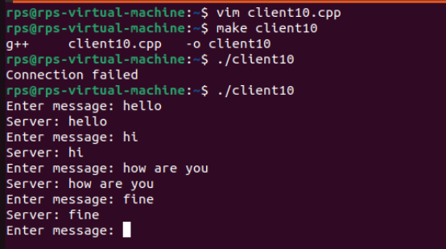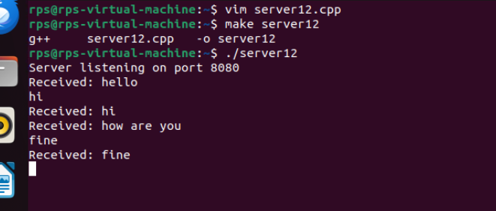

**SERVER CODE:**

#include <stdio.h>

#include <stdlib.h>

#include <string.h>

#include <unistd.h>

#include <arpa/inet.h>

#include <pthread.h>

#define PORT 8080

#define BUFFER_SIZE 1024

void* handle_client(void* arg) {

int client_socket = (int)arg;

char buffer[BUFFER_SIZE];

int bytes_received;

while ((bytes_received = recv(client_socket, buffer, BUFFER_SIZE, 0)) > 0) {

buffer[bytes_received] = '\0';

printf("Received: %s\n", buffer);

send(client_socket, buffer, bytes_received, 0); // Echo back to client

}

close(client_socket);

free(arg);

return NULL;

}

int main() {

int server_socket;

int *client_socket;

struct sockaddr_in server_addr, client_addr;

socklen_t client_addr_len = sizeof(client_addr);

pthread_t thread_id;

// Create socket

server_socket = socket(AF_INET, SOCK_STREAM, 0);

if (server_socket == -1) {

perror("Socket creation failed");

exit(EXIT_FAILURE);

}

// Bind socket to address

server_addr.sin_family = AF_INET;

server_addr.sin_addr.s_addr = INADDR_ANY;

server_addr.sin_port = htons(PORT);

if (bind(server_socket, (struct sockaddr*)&server_addr, sizeof(server_addr)) == -1) {

perror("Bind failed");

close(server_socket);

exit(EXIT_FAILURE);

}

// Listen for incoming connections

if (listen(server_socket, 5) == -1) {

perror("Listen failed");

close(server_socket);

exit(EXIT_FAILURE);

}

printf("Server listening on port %d\n", PORT);

// Accept and handle incoming connections

while (1) {

client_socket = (int*)malloc(sizeof(int));

if (client_socket == NULL) {

perror("Failed to allocate memory for client socket");

continue;

}

client_socket = accept(server_socket, (struct sockaddr)&client_addr, &client_addr_len);

if (*client_socket == -1) {

perror("Accept failed");

free(client_socket);

continue;

}

if (pthread_create(&thread_id, NULL, handle_client, client_socket) != 0) {

perror("Thread creation failed");

close(*client_socket);

free(client_socket);

continue;

}

pthread_detach(thread_id);

}

close(server_socket);

return 0;

}

**CLIENT CODE:**

#include <iostream>

#include <cstring>

#include <unistd.h>

#include <arpa/inet.h>

#define PORT 8080

#define BUFFER_SIZE 1024

int main() {

int sock = 0;

struct sockaddr_in serv_addr;

char buffer[BUFFER_SIZE] = {0};

if ((sock = socket(AF_INET, SOCK_STREAM, 0)) < 0) {

std::cerr << "Socket creation error" << std::endl;

return -1;

}

serv_addr.sin_family = AF_INET;

serv_addr.sin_port = htons(PORT);

// Convert IPv4 and IPv6 addresses from text to binary form

if (inet_pton(AF_INET, "127.0.0.1", &serv_addr.sin_addr) <= 0) {

std::cerr << "Invalid address / Address not supported" << std::endl;

return -1;

}

if (connect(sock, (struct sockaddr*)&serv_addr, sizeof(serv_addr)) < 0) {

std::cerr << "Connection failed" << std::endl;

return -1;

}

while (true) {

std::cout << "Enter message: ";

std::string message;

std::getline(std::cin, message);

send(sock, message.c_str(), message.size(), 0);

int valread = read(sock, buffer, BUFFER_SIZE);

std::cout << "Server: " << buffer << std::endl;

memset(buffer, 0, BUFFER_SIZE);

}

close(sock);

return 0;

}